Solar-Log GmbH at the EM-Power Europe 2024

Manage PV systems flexibly and utilise synergies

Geislingen-Binsdorf (Germany), 13.05.2023

The countdown is on. A few more weeks and Intersolar 2024 with its numerous themed trade fairs will begin. Solar-Log GmbH will be there again this year, exhibiting at stand B5.116 at EM-Power Europe. This time, the focus of the energy management system was on new developments that support the efficient operation of PV systems in particular.

Enerest ToGo Version 8 - The app for mobile energy management
The Enerest ToGo app, which is available to download free of charge for Apple and Android devices, offers extensive functions for installers and system owners alike. The app offers numerous options, whether for installing the energy management system to track faults while travelling or to have a quick overview of production and consumption values.
Version 8 of EM-Power Europe brings numerous exciting features for mobile energy management.
With the new filter function in the alarm list, alarm messages can be filtered so that only active alarms are displayed. This means that the overview of alarm messages is not lost and alarms that require active action are no longer overlooked. Another new feature is the display of the inverters in a separate diagram. Here too, the focus is on clarity and the recording of all relevant data. The value for standardised production in W/Wp has been added as additional information.
Further innovations that come with version 8 are the manual correction of data in the data matrix. This allows individual adjustments to be made and monitoring to be used in a more targeted manner. To get answers to possible questions more quickly, there is also a direct link to the online help and useful tutorial chapters in a new format.
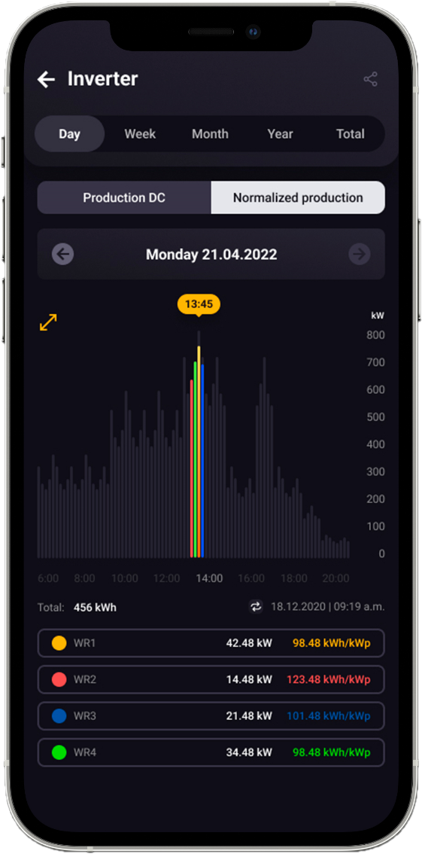

Solar-Log WEB Enerest™ 4 - New features
Photovoltaic systems represent a not inconsiderable investment. In order to safeguard the investment, the yields of the system must be ensured. The energy management system plays a key role here by immediately recognising and reporting faults, among other things. With its Solar-Log WEB Enerest™ 4 portal, the Solar-Log energy management system provides users with a tool that enables them to manage, control and monitor one or more PV systems.

Automations - customised adaptations to your own needs
With Enerest Automations, Solar-Log is introducing a new function for the Solar-Log WEB Enerest™ 4 portal. Automations is a solution for creating rules without code, i.e. rules are created on the basis of events from the Solar-Log WEB Enerest™ 4 according to the "If this, then that" principle. The rules can be set up in such a way that they correspond to the individual requirements of the user.
For example, the following can be defined: "If an alarm is detected, an email is sent to the user." This allows users to tailor their portal and its functions even more precisely to their needs and optimise it to suit their individual requirements.
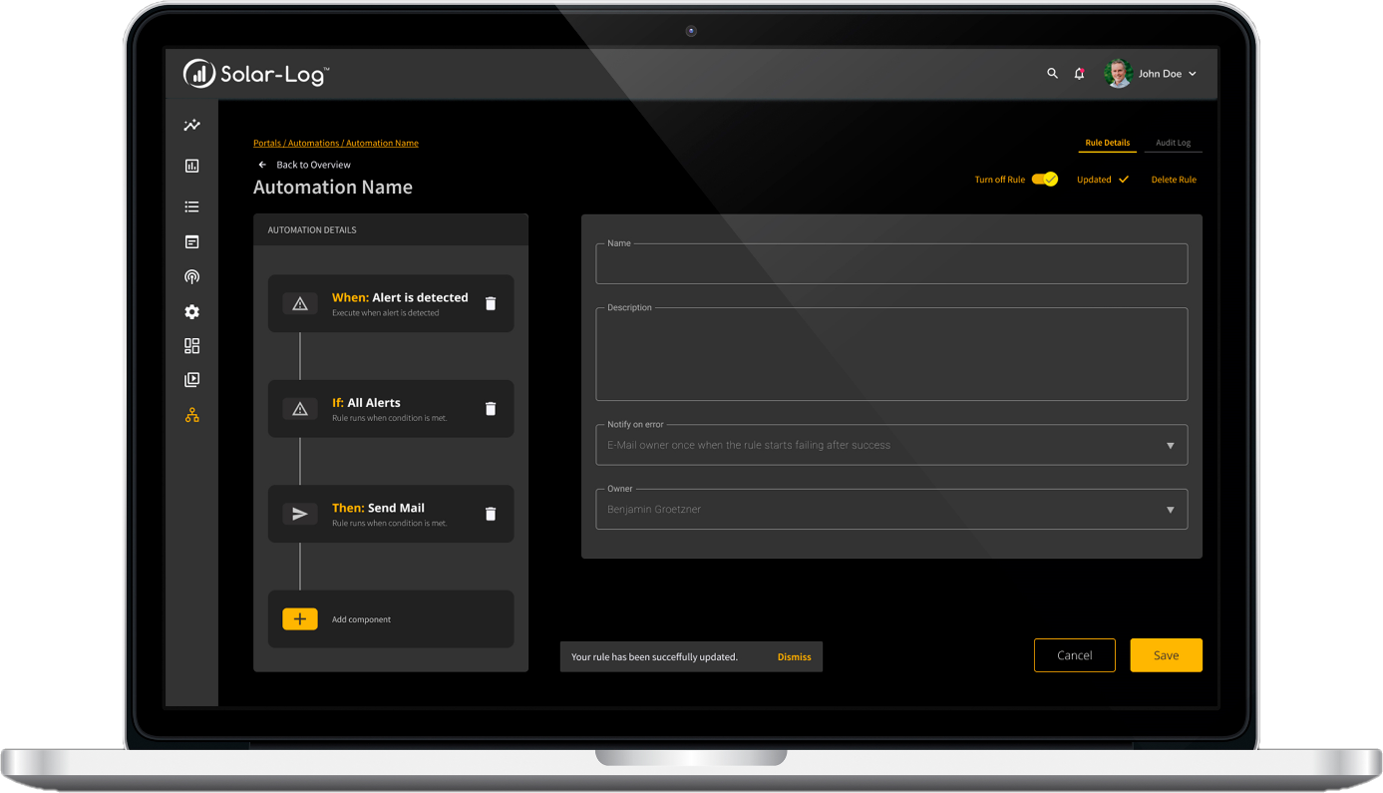

User API - the interface for further data utilisation
With the User API, users will be able to request API access for their systems in future. Previously, this function was only available to Portal Managers, who have access to all systems in the portal.
The User API enables users to request data via the interface and only see the PV systems assigned to them. Plant managers can set up access via API for individual (major) customers so that they can integrate the data into their own systems and process it further.

About Solar-Log GmbH
Solar-Log GmbH is one of the leading companies in the fields of PV monitoring, smart energy and feed-in management. Solar-Log™ hardware and software products are used in over 141 countries worldwide to monitor photovoltaic systems, optimise self-consumption and control energy feed-in to the power grid. The portfolio in the Solar-Log WEB Enerest™ monitoring platform includes over 405,000 systems with a capacity of over 17 GWp.
Solar-Log™ has been a subsidiary of BKW AG since August 2015. BKW AG is an internationally active energy and infrastructure company based in Bern (CH).

Press contact
Solar-Log GmbH
Mr Jörg Niche
Fuhrmannstrasse 9
72351 Geislingen-Binsdorf

Phone: +49 7428 4089-327
Email: press@solar-log.com

